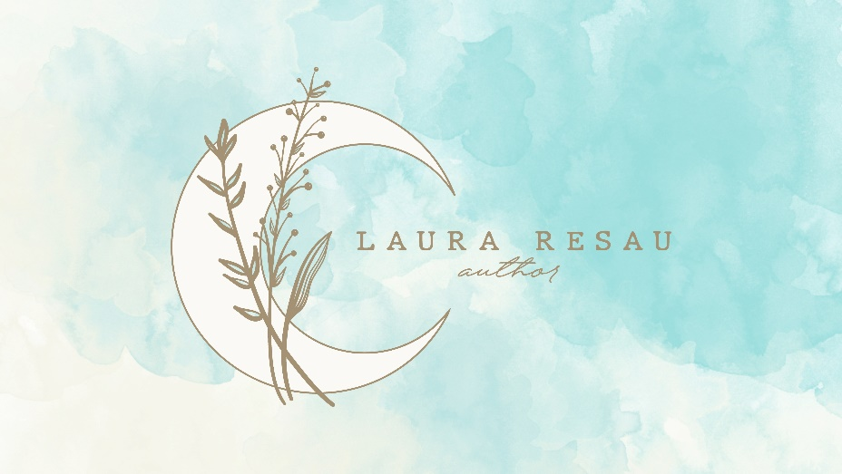

Your Book-in-Progress Consultation

with Author Laura Resau

About Your Consultation

Laura offers expert, tailored advice on the next steps to take for your manuscript for a picture book, middle grade, young adult, or adult book (fiction or non-fiction.) This will be most useful to you if you’ve already completed some or all of your manuscript (or, in the case of non-fiction, your proposal and sample chapters.) She gives clear, helpful feedback with a positive vibe!

Example topics you might want to discuss include trouble-shooting big-picture issues in your manuscript, strategizing agent submissions, figuring out the strongest way to pitch your book, making sure your vital first pages shine, crafting a captivating query, discussing how to pitch your work, understanding the current market for your genre, deciding whether traditional or self-publishing options are best for you, or other issues at this point in your book-writing/publishing journey.

Package 1
Pick Laura’s Brain

A one-hour consultation with Laura, either online, by phone, or in-person. Cost: $150

Package 2
Pick Laura’s Brain & Get Written Feedback on Your Work

You’ll get written feedback on your materials, tailored to your needs.
  - Laura will provide feedback on your agent query letter plus the first ten pages plus short synopsis (or outline or proposal.)
OR
  - Laura will provide feedback on the first twenty-five pages of your manuscript plus synopsis (or outline or proposal.)
OR
  - In the case of a picture book, Laura will provide feedback on the entire manuscript (less than 2000 words) plus your agent query letter.

You’ll also get a one-hour consultation with Laura, either online, by phone, or in-person. This meeting is tailored to your specific needs and can come before or after she reviews and provides notes on your submitted materials, depending on your preference. Cost: $250

How to Book Your Consultation

Email LauraResau@gmail.com, subject “Book Consultation.” Please include:
- A brief description of your book project and what you’re looking to get out of the consultation, including your main questions and topics to cover.
- Your timeline and some days/times available for meeting about your book.
  - If you’d like to meet in person, Laura can meet you at a quiet coffee/tea house in Old Town, Fort Collins.

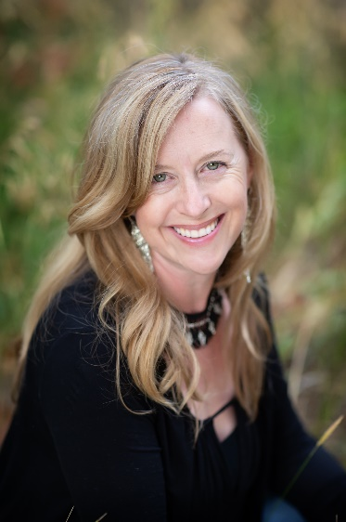
Laura Resau is the award-winning author of nine highly acclaimed young adult and children’s books with Delacorte and Scholastic as well as the forthcoming Stand as Tall as the Trees: How an Amazonian Community Protected the Rain Forest (with Patricia Gualinga, Summer 2023), and Virch (Fall 2023). Loved by kids and adults, her novels have garnered many starred reviews and honors, including the IRA YA Fiction Award, the Américas Award, five Colorado Book Awards, and spots on “best-of” booklists from Oprah, School Library Journal, the American Library Association, Bank Street, and more.
Laura's writing has been called "vibrant, large-hearted" (Publishers' Weekly on Red Glass) and "powerful, magical" (Booklist on What the Moon Saw). Currently branching out into upmarket women’s fiction, she is revising her novel manuscript with her agent. Learn more about Laura and her books at https://www.LauraResau.com.

